

International Journal of ChemTech Research
CODEN(USA): IJCRGG ISSN : 0974-4290
Vol.4, No.2, pp 546-552, April-June 2012

Physiochemical Microbial and Pharmacological studies of Zn (II) - Melphalan complex

Birjesh singh¹*, Jyotsna Mishra² and Alka pradhan³
^{1,2}Department of Chemistry, Institute of Science and Technology, AISECT University, Bhopal (MP), India.
³Department of Chemistry, MVM College, Bhopal (M.P), India.

*Corres.author: vision_bsin@yahoo.com

Abstract: The anticancer drug Melphalan and its complex with Zn(II) have been qualitative and quantitative analysed spectrometrically and electrochemically.
All the studies have been done in both phases i.e. solid and liquid. On the basis of elemental analysis, IR spectrometry, Polarography and Amperometric methods the probably formula of the complex has been worked out to be 1:2 (M: L).
Antimicrobial activity of complex has been determined using Disc diffusion method against various pathogenic bacteria and fungi. Obtained results is in increased inhibition efficiency against the prepared complex, it is presumed that the complex may prove to be more potent as compared to melphalan drug.
Pharmacological studies (In-Vitro and In-vivo) of prepared drug complex were done on B16F10 myeloma cell and C57BL mice. The observed results revealed that the complex is more potent as compared to the pure drug in all above mentioned activities. As such Zn(II) melphalan complex may be recommended to the therapeutic expert for its possible use as more potent anticancer drug.
Key words – Bioinorganic, anticancer drug, Zinc complex, polarography, pharmacology.

Introduction
Melphalan is an antineoplastic drug. It is also used as immunosuppressive agent (1). Chemically it is a ([4-(bis-2Chloroethyle) amino] L-phenyl amine) and its biological activity is related to the ability to function as an alkylating agent in physiological conditions. The designs of a drug for treatment of any particular disease depend on the development of suitable chemical criteria for in-vitro and in-vivo reactions.
Zn (II) is recognized as an essential metal for normal functioning of our biological system. It is a major constituent of many enzymes involved in the metabolism of DNA and RNA (2). Zn deficiency is associated with impaired growth and large number of diseases (3). Beside several other important role of Zn in our body system are well known (4-5). It has been observed in favorable cases that metal drug complexes show increase potency then the parent drug (6). Keeping this view in mind the present investigation deal with the bioinorganic studies of the interacting such biologically essential metal Zn(II) and an anticancer drug melphalan. Change in the biological properties of the melphalan have been evaluated and underlying role of Zn(II) in the anticancer activity of pure drug has been discussed.
The study on Zinc complexes of anticancer drug melphalan have carried out by physico- chemically, microbially and pharmacologically. The metal ligand complexation equilibrium have been studied using elemental analysis, amperometric titration and voltametric / polarographic studies. Besides, IR spectral analysis has been worked out which gives probable formula for the complex is to be 1:2. Various pathogenic bacteria like Klebsiella Pneumonia, Pseudomonas, Staphylococcus aureus and fungi i.e. Asperginus niger, Nigrosporan sp. have been used to microbial study using disc diffusion method. B16 F10 myeloma cell and C-57BL mice were used for the in-vitro and in-vivo anticancer study of complexes respectively. The result of physicochemical method, microbial and pharmacological studies with the Zn-melphalan complex suggested that the recommendation of prepared complex to the therapeutic experts for its possible use as more potent anticancer drug.

Experimental
All the chemicals used were of analytical grade, sigma laboratory, USA supplied the Melphalan drug. Standard solution of Zn (II) 0.5 mM melphalan 1mM and potassium chloride 0.1 M were 5% of 95% ethyl alcohol prepared was kept.

Electrochemical studies
The DCP and DPP studies were carried out in Exploratory mode and peak analysis in determination mode on a software connected Ω Metrohm 757 VA Computrace (Ion analyzer).The polarographic cell consisted of a three electrode assembly and a stirrer having a dropping mercury electrode (DME) as a working electrode, a platinum wire as an auxiliary electrode and Ag/AgCl electrode as reference electrodes. The nitrogen gas was bubbled for 5 minutes. A systronics digital pH meter model-361 was used for pH measurements.
Different sets of solution containing over all concentration of Zn (II) 0.5 mM in 0.1M KCl with varying concentration of Melphalan from 0.5 to 15mM, were prepared. The pH of these solutions was adjusted to 6.0±0. Nitrogen gas was bubbled through the test solution for about 15 minutes before recording the polarograms.
The AJCO potentiometer apparatus was used for amperometric titration consisted of a DME as working electrode, a calomel electrode as reference electrode and attached to an AJCO Vernier Potentiometer. Characteristics of the DME had m^{2/3}t^{1/6}= 2.5mg^{2/3}sec^{-1/2} at 60cm effective height of mercury column.
For amperometric titration, set of solution containing varying concentration of Zn(II) (over all concentration, 0.5mM, 1mM, 1.5mM) in 0.1M KCl as supporting electrolyte were prepared and pH was adjusted to 6.0±0.1, using dil HCl/ NaOH. The plateau potential for Zn (II) is -1.1V versus SCE was fixed on the potentiometer. The titration were performed using melphalan solution as titrant.

Synthesis of Solid Complex
A white coloured complexes was synthesized by refluxing aqueous solution of M: L Zn(II) and melphalan (1:2) molar ratio for about 3 hours. The complex was marked by precipitation after reducing, the volume of reaction mixture to one fourth of the original volume. The product was filtered, washed dried over P₄O₁₀ and characterized.
The elemental C,H,N,O, analysis of complexe was done on a hearaus varlo Erba Elemental analyzer Model- 1108, at CDRI Lucknow,where as gravimetric method was used for the estimation of Zinc in Zn-melphalan complex(7).

Spectrometric measurement
The IR spectrophotometric analysis was performed in solution phase using Shimadzu Corporation FTIR-spectrometer, model-8400S

Antimicrobial Screening
Disc diffusion method (8-9) was followed for the microbial screening of Zn(II)-melphalan complexe against bacteria viz Klebsiella pneumonia, Pseudomonas aeruginasa, Straphylococus aureus and fungi i.e. Asperginus niger Nigrosporas SP.. Number of replicates in each of the case was three; percentage inhibition was calculated using the formula
Percentage inhibition =
Where a= diameter of inhibition zone for control (melphalan), b=diameter of inhibition zone for complex

Pharmacological studies
In-vitro and In-vivo study of anticancer activity of prepared metal drug complex have been done by following procedure (10-12)
In-vitro: - Mouse myeloma cell line- B16F10, obtained from national center of cell science, Pune India, as a monolayer culture in roux bottles (corning plastics, USA).
The cells obtained were cultured in 5ml 24 well culture plate (corning plastics, USA). The cells were seeded in 2x10⁵ cells per well and 1.0 ml of dulbecco’s modified Eagles medium (DMEM) contain 10% V/V foetalcalf serum, penicillin 100 μg/ml and streptomycin 100 μg/ml was added to each well. The cells were kept in incubator at 37˚c of 4h in 5% CO₂ atmosphere and 95% humidity. The cell counter was made on neubaurs chamber (fine optic, Germany).
Three dilution Viz 1μm, 10 μm, and 100μm of pure drug and its Zn Complex were made and then the cells were treated as follows.

Column | Free drug | column | Metal complex
A | 1μm (1ML) | A | 1μm (1ML)
B | 10μm (1ML) | B | 10μm (1ML)
C | 100μm (1ML) | C | 100μm (1ML)

After addition of respective solutions, the culture plate was incubated at 37˚c for four hour’s finally the cell counts were made as under. There are compared with the cell cultured in DMEM with treatment.

Cell viability counts:-
Cell viability counts were made by trypan blue dye exclusion test. Two drops of trypan blue were added to each cell culture well and kept for 15 minutes now a drop of culture was added to hemocytometer (Neubaurs chamber) and the number of stained, non stained and total number of cells were counted, then the % inhibition was calculated using the equation.

No of viable cells – No of viable cells after treatment x 100/
No of viable cell without treatment
The experiment of each concentration of the drug and the complex was repeated thrice and statistical conclusions were drawn.
In-vivo: - The comparative efficiency of pure and complex form of melphalan drug evaluated from the difference in response after treatment with two forms of drug.
Animal model: - C 57BL mice Weight 30-40gm
Tumor model: Myeloma cell line B16F10
Drug : Melphalan and its Zn complex

Cell growing in nutrient medium (DMEM) were obtained from NCCS, Pune. They were brought into single cell suspension by trypsinization (0.2% trypsin). The cell suspension (1-2 X 10 cell/ml).Approximately 10⁵ of cells of tumor were injected on the dorsal surface of the mouse and allowed to grow palpable size was reached by 6-8 days.
The time required to double the tumor volume (volume doubling time ,VDT) from 100 to 200 mm was taken as a criterion to assess the antitumor efficiency of pure and complex drug in myeloma cell line B16F10 tumor bearing mice. The treatment was started after tumor size reach 100±10 mm³ .
Indicated dose (equivalent to 0.2mg) of free drug complex were injected intravenously and tumor growth was monitored. Tumor Size was calculated by the formula ½ LW² where L-long diameter and W- short diameter of the tumor. The above In-vivo experiment was repeated on two other set of mice groups.

Fig-1 polarogram of Zn(II) (0.5mM) in 0.1M KCL supporting electrolyte at pH 6.0±0.01
And 1.0mM Melphalan
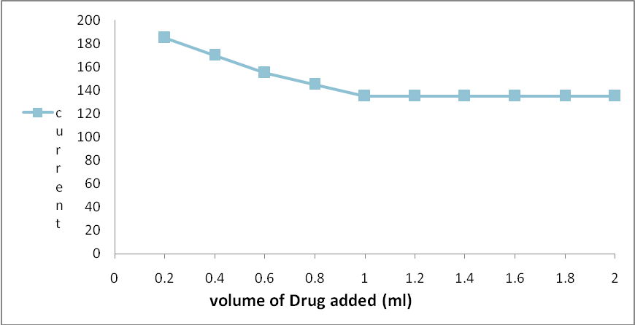
Fig-2 Amperrometric titration of (1mM/10ml)melphalan (0.5mM/ml)
Z(II) solution in 0.1 M KCl Solution

Fig-3 IR Spectrogram of Zn(II)-Melphalan complex

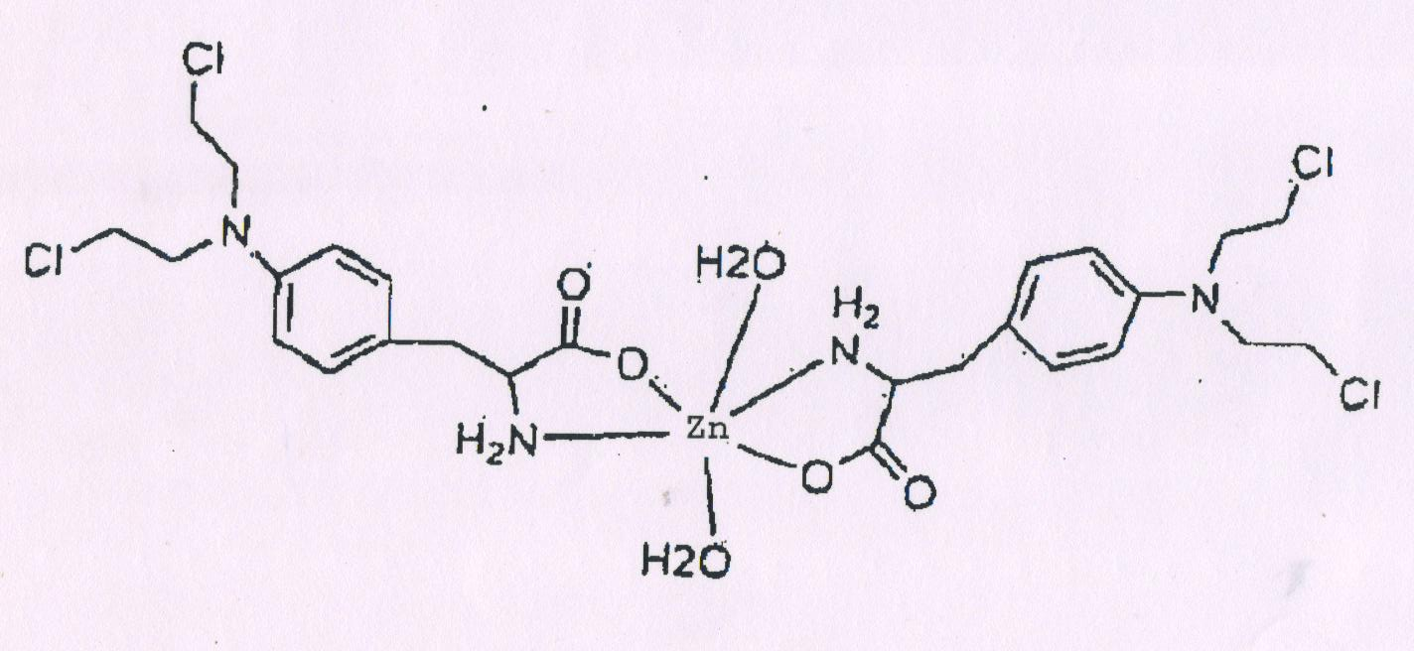
Fig-4 Zn (II) - Melphalan complex Structure

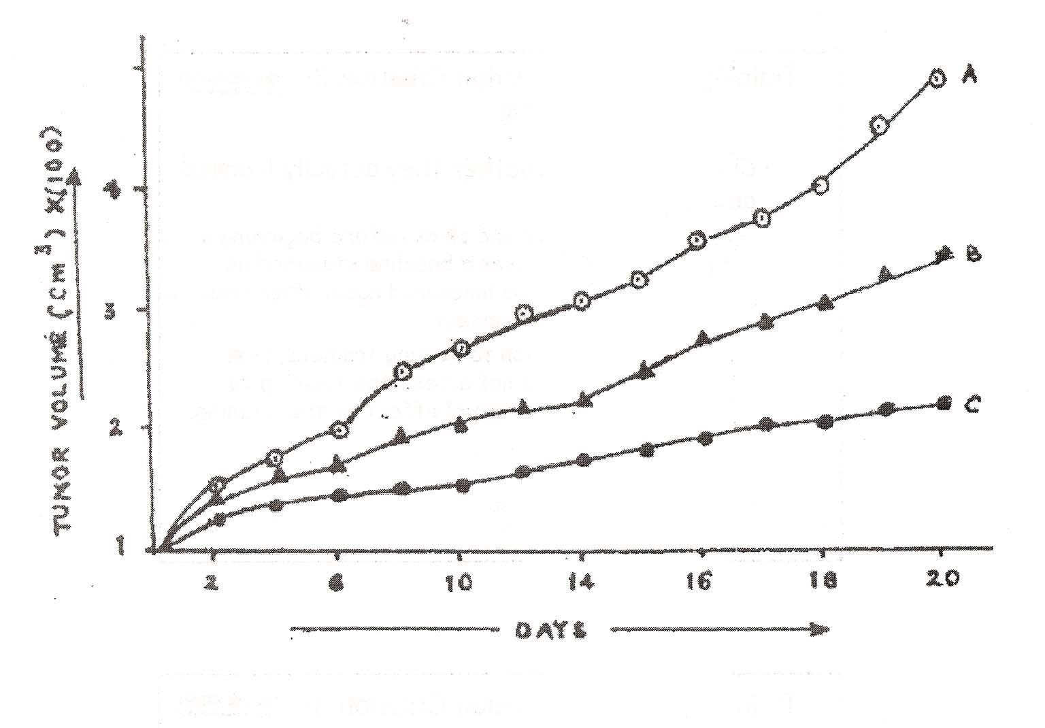

Fig-5 Effect of Zn(II)-Melphalan
Melphalan complex on tumor volume.
A-Without drug
B-With melphalan
C-With Zn(II)- melphalan

Table- 1: Result of Elemental Analysis (%)
Element | Melphalan | Zn(II)-Melphalan
Zn | - | 9.21  (10.46)
C | 51.16  (51.1) | 43.99  (44.0)
H | 5.94  (6.0) | 5.35  (5.72)
O | 14.48  (14.81) | 13.51  (13.20)
N | 9.18  (8.9) | 7.89  (7.42)
Cl | 23.3  (23.2) | 19.94  (19.90)

Table-2: Result of Antibacterial Activity of Melphalan and It’s Zn(II)-Melphalan complex
Test Organism  (A-Bacteria) | Zone of inhibition |  | % Inhibition
Test Organism  (A-Bacteria) | Control (mm) | Complex (mm) | % Inhibition
Staphylcoccus aureus | 7 | 10 | -42.85
Klebsiella pneumania | - | 3 | -
Prosteus | 8 | 13 | -62.5
(B-Fungi)  Asperginus niger | 6 | 10 | -66.6
Nigrosporan SP | 05 | 09 | -80

Table-3 : Results of In vitro cytotoxicity of melphalan and Zn(II)- melphalan complex against Myeloma tumor cell Line B16 F10
Compound | Concentration μM/ml | % inhibition after 4h
Melphalan  Zn (II)- melphalan  Complex | 1.0  10.0  100.0  1.0  10.0  100.0 | 36.4 ± 1.0(a) (b)  54.7 ± 2.6  78.6 ± 1.8  52.1 ± 1.0  69.8 ± 1.6  92.5 ± 1.9

Result and discussion
Polarographic behavior of Zn (II)-melphalan complexes
In 0.1 M KCl at 6.0±0.1 pH, Zn(II) and its complexes with melphalan, produced a well defined reversible and diffusion controlled polarographic wave which revealed by the log plot slop id versus √h (effective height of mercury column) respectively. On gradual addition of ligand, the E_{½} of metal shifted to more electronegative value, indicating the formation of complex (Fig.-1). Lingane treatment (13) of observed polarographic data reveled 1:2 [M: L] complexes formation in solution with logβ₁ = 5.678

Amperometric titration of melphalan with Zn (II)
Zn(II) with melphalan gives a well defined polarographic waves/peak in 0.1M KCL at 6.0±0.1 pH. the diffusion current was found proportional to the concentration of Zn(II). The platue potential for the polarographic wave Zn (II) (-1.1v) vs Hg pool was applied for carrying out amperometric titration.
The current goes on decreasing to minimum and then attends a constant value. The plot of id (V+vV) versus volume of titrate added, revealed L shaped curve (Fig-2). The end point was indicated by the intersection of the two lines, which confirmed 1:2, [M: L] complexes formation

Characterization of (Zn (II)-Melphalan) solid complexs
Colour: - white
Solubility: - Water soluble

Elemental analysis
Percentage of C, N, O, H, and Zn found and calculated in complex and melphalan drug are summarized in Table-1

Spectrometric analysis
The structurally important frequencies of IR bands for melphalan and its complexes with Zn(II) metal ion have been shows in Fig-3.
A comparison of IR data for the drug and it’s complexes reveals that the bands at 1400 and 1590 cm⁻¹ in the drug are shifted to 1740cm⁻¹ in the spectrum of complex, indicated the involvement of carboxylic group and amino group in complex formation.
On the basis of elemental analysis, polarographic , amperometric studies and IR spectra, a tentative structure to the Zn(II)-melphalan complex may be assigned as shown in Fig-4.

Antimicrobial activity
Antimicrobial behavior of the Zn(II)- melphalan complex against various pathogenic bacteria and fungi has been reported in the Table-2. A perusal of the data in Table reveals that complex shown increased toxic effects against all the pathogenic bacteria under study, as compared to the parent drug melphalan

Pharmacological studies
In Vitro
The result of in vitro experiments of pure drug and its complex are shown in Table-3. A perusal of the results data in Table that Zinc- melphalan complex was found to be more effective than pure drug. The complex under study shows in increased inhibition against the Myeloma cell line B16F10 tumor cells at all the test concentration i.e. 1,10,100 μm /ML. The increased inhibition activity of the complex was 52.1±1.0%, 69.8±1.0% and 92.5±0.9% as against 36.4±1.0%, 54.7±0.6% and 78.6±0.8% shown by the drug, respectively. The statistical treatment of observed inhibition data i.e. standard deviation and coefficient of variance which never exceeded 0.9 and 18% respectively, speaks the reliability of the observed inhibition data.

In vivo
The result of the average of mice tumor against melphalan drug and zinc complex under study are shows in (Fig.5) The results indicated that the tumor volume was 0.05 cm² on the tumor cell injected mice without administering drug or complex after 20 days, percentage which was reduced to 0.035cm² on tumor injected mice who were also administered the melphalan drug. However, in case of Zn(II) melphalan administered mice(tumor cell injected) shows significant decrease in the tumor volume of 0.018cm² was observed. Thus indicating the increasing in vivo tumor inhibition power of the complex over the drug under study in the experimental time periods i.e. 20 days.

References
- Remington’s Pharmaceutical Sciences , Mack publishing Co., Easton, Pennsylvania, 6th Ed.,1092(1980)
- Golden MHN, Jackos AA, Golden BE, Lancent, 2, 1057(1977).
- Jameson S,Acta Med.Scand. Supp., 21,593 (1979).
- Das MK, Gosh S, Indian J.Chem. 36(A-10), 324 (1997).
- Zabin SA, Jejukar CR, Indian J. Chem.,36(A-5),435(1997).
- Shukla J, Pitre KS, Indian J. Physiol Pharmacol, 42(2),223-230(1998).
- Mastrolorenzo, Supuran CT, Metal based drug.7, 1, 49(2000).

- Murray PR, Baron EJ, Pfallar MA, Tenover FC, Yolke Rh Manual of Clinical Microbiology , 6th Ed. Vol-6, Washington DC 214-215,(1995).
- Zavala SMA, Perez GS, Phytotheraphy Res. 11, 368-371(1997).
- Devi PU, Sharoda AC, Soloman FE, Kamath MS, Indian J. Expl Biol, 169(1992).
- Ghosh MN Fundamentals of experimental pharmacology, Scientific book agency, 2nd Ed. 153(1984).
- Devi PU, Sharoda AC, Soloman FE, Kamath MS, Indian J. Expl Biol, 607(1993).
- Lingane JJ, Chem. Rev.,1, 29(1941)

*****

